WALSOKEN PARISH COUNCIL
Minutes of the Walsoken Parish Council Meeting held at Walsoken Village Hall
on Wednesday the 5th of March 2025 from 7.00pm
Present:
Councillors – Fred Leach - Chair, John Woolley – Vice Chair, John Harwin, Clive Bettinson, Lynn Clarke, Chris Luff, Jenny Snow, Andy Houghton, Jo Taylor, Julian Kirk, and Lynn Ottaviano, Parish Clerk
No members of the Public

- Welcome from Chairman to everyone.
Public Participation – to allow public participation (3 minutes per speaker, up to a maximum of 15 minutes in total). None

- Apologies Cllr Dawson.

- Declarations of Interest of any items on the agenda and to consider any requests for dispensations. None

- Approval of the Parish Council Meeting minutes held on the 8th of January 2025 were proposed by Cllr Clarke, seconded by Cllr Harwin and approved by all present at that meeting.

- Matters Arising – to record matters arising from the last meeting:
  - Sleights Drive

Councillor Leach stated that he had concerns about the proposed work for Sleights Drive which had been discussed at an earlier meeting. His concerns were that the Parish Council would spend money to have the area improved but if it then wasn’t maintained by the Borough council it would revert to how it was, and the money would be wasted. Cllr Leach had attended a meeting with Jason Moorse from NCC about grass cutting in the area and how NCC would give the parish council money to arrange their own grass cutting. However, Sleights Drive, along with other areas in the village were not listed and so there is uncertainty over who is responsible for maintaining the area. Cllr Leach gave further details about the meeting with NCC. After further discussion, it was decided that Cllrs Leach and Kirk would investigate who is responsible for the upkeep of the land at Sleights Drive and then further discussion would be had.

  - Defibrillator battery

Cllr Clarke reported that she has no updates on the hairdresser’s possible sale date. The council proposed to purchase a new battery for the defibrillator. To be purchased by the clerk who will liaise with the defibrillator guardian about fitting the battery.

  - Speed survey

The clerk reported that there are no results yet for the speed survey as it is still ongoing. She will email the councillors with the results when available, for discussion at next meeting.

  - Updated budget

The clerk reported that the budget remains mostly unchanged except for an increase in the amount for dog bin emptying and an increase in the clerk’s wages as per national wage increase. The clerk will update the budget sheet at the end of March.

  - Clerk’s wages

The clerk reported that there had been a national pay increase for local clerks and that her hourly rate has been increased to £14.60 an hour.

- To receive reports:
  - Councillors’ reports of villagers’ concerns, highway issues, allotments, and street lighting.
Cllr Houghton reported that there is a large pothole in the village that he will try and take a photo of. Cllr Kirk spoke about putting up more signage in the village which he may be able to arrange funding for and also about purchasing another litter bin. Cllr Kirk to contact Jason Moorse about the possibility of funding for these items and also to see if it would cover grass cutting.
  - County and Borough Councillors reports
Cllr Kirk reported that he would be contacting the planning department about the new application at Sibley House and also about the expanding traveller site at Biggs Road. Cllr Bettinson reported that the site is expanding and that hardcore has been put down and fencing put up. Cllr Kirk suggested that council members contact the planning department individually if they wish, to share their concerns. The Biggs Road planning application is an old application from 2023, 23/01082/F.

  - Clerk Report
The clerk reported that she has requested for Keven Brooks to be the Internal Auditor again this year. She has recently attended two webinars on the year end and completion of the AGAR in preparation for April. The clerk reported that she has resubscribed to Scribe Accounts for the following year. The clerk has been contacted by the editor of the Walsoken local magazine who has asked if the parish council would like to put in meeting dates and information in the publication. The clerk informed the parish council that she had received a thank you email about the placement of bus timetables in the new bus shelters.

  - Churchyard matters
Cllr Leach awaiting quotations for the cost of new church gates. Tawny Owl should be commencing grass cutting by the 14th of March in the churchyard.

Village Hall
Cllr Wooley reported that the village hall committee have met twice since the last parish council meeting, reports as follows:

Monday 13th January 2025 meeting
The hall floor is problematic, and it was agreed to get quotes to have it cleaned and sealed professionally.
Signs for the car park were discussed, and it was decided to order signs stating that is it a private car park for the use of the hall users only as the car park is being used by motorists not connected with the village hall.
Questions were asked about who is available to let people into the hall for repair work etc., and John Woolley offered but has no keys. It was arranged for keys to be provided for him.

Monday 10th February 2025 meeting
The oil-fired boiler is over thirty years old and has been causing problems so a quote for a new one has been obtained from Simon Dack boiler services. The cost is £4500. Further quotes are to be obtained as it was proposed that grant money should be applied for.
Quotes for cleaning and sealing the floor have been received ranging from £5700 plus VAT to £4850 including VAT. Again, it was proposed that grant money be applied for.
It was discussed and agreed that the only bar to be available for hall events is the bar in the hall manned by David Patrick and his staff.

Communications and Correspondence:
Email regarding bus timetables from Parishioner (as mentioned in Clerk’s report).

- Planning:
7.1. To receive results of applications, decisions, appeals and enforcements.

24/01815/RMM Walsoken Land South of Grassgate Farm Grassgate Lane Walsoken
Norfolk - RESERVED MATTERS APPLICATION FOR :
All reserved matters for 9no. commercial / industrial
buildings
Application Permitted
10 January 2025
Delegated Decision

24/02240/LDP Walsoken Land E of Zoar Cottage Green Lane Walsoken Norfolk -
LAWFUL DEVELOPMENT CERTIFICATE- Creation of
caravan on site required for 24/7 security purposes
Not Lawful
11 February 2025
Delegated Decision
The clerk read out the following planning decision which was received after the agenda had been sent out:
24/02080/F Walsoken Shell Service Station Light Lane Walton Highway Wisbech

Norfolk PE14 7BF
- De-Commissioning and Removal of Old Fuel Tank
and Installation of New Underground Fuel Tanks,
Replacement Pumps, Sales Building Extension to
provide Enhanced Toilet Provision and Associated
Works

Application Permitted
21 February 2025
Delegated Decision

7.2. To receive new applications and comment. (Any applications received after the date of this agenda and before the meeting date will be considered).

25/00250/F
Details: HOUSEHOLDER- Single storey side extension to form accessible bedroom and
bathroom. at 68 Chapnall Close Walsoken WISBECH Norfolk PE13 3TZ
The councillors all voted in favour of this application.

25/00284/O
Details: OUTLINE PLANNING PERMISSION WITH SOME MATTERS RESERVED FOR:
Proposed Custom/Self-Build Dwelling. at Land Rear of 1 To 3 Griffin Close
Griffin Close Walsoken Norfolk
Councillors to review this application and let the clerk know their thoughts.

25/00275/F
Details: Proposed erection of kennel buildings, within the confines of existing buildings
(to be repaired made good) and creation of external exercise area for operational
use. at Sibley House Station Road Walsoken Wisbech Norfolk PE14 8DL
Councillors all voted against this application. Some of the reasons stated were noise, nuisance, current poor housing, and loose dogs causing a danger to public and livestock.
25/00285/F
Details: SELF BUILD- Proposed dwelling and car port at Land North of Fairhaven Lynn
Road Walsoken Norfolk
Councillors to review this application and let the clerk know their thoughts.

- Finance
  - Approve payments, receipts, bank reconciliation and statements for January 2025 and February 2025. Proposed by Cllr John Woolley and seconded by Cllr Clarke.
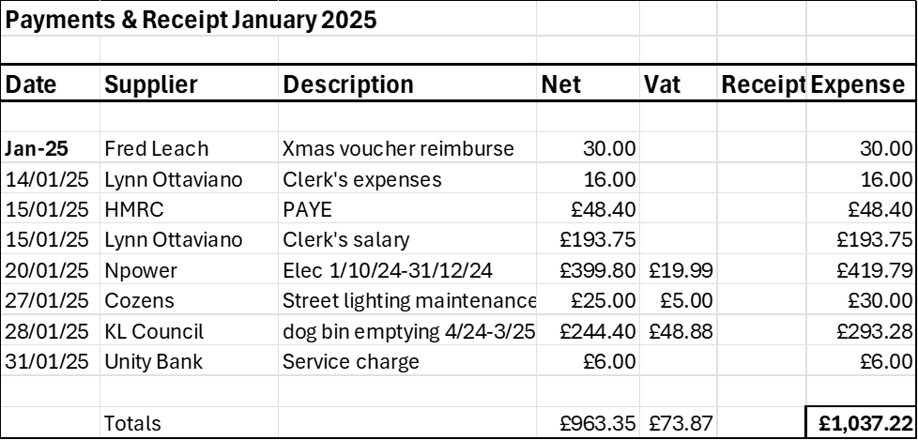

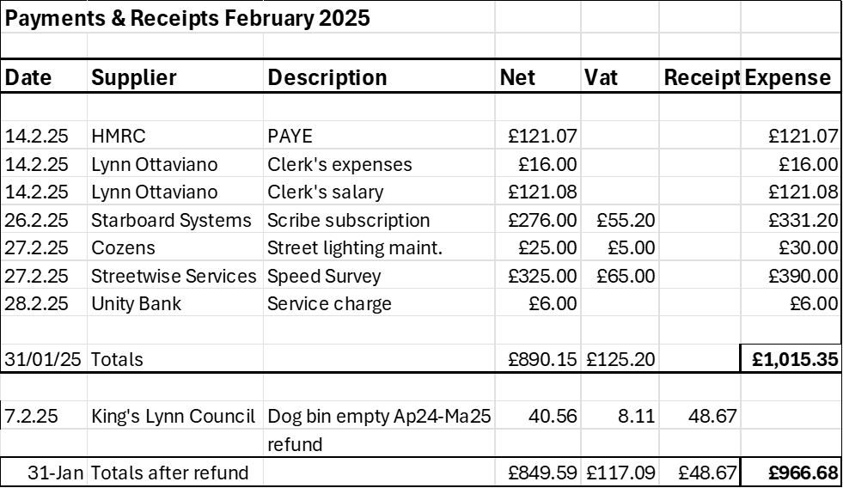

  - To approve payments for March 2025. Note, due to the early date of this meeting any payments received after the meeting will be forwarded for approval. Proposed by Cllr Jo Woolley and seconded by Cllr John Woolley.
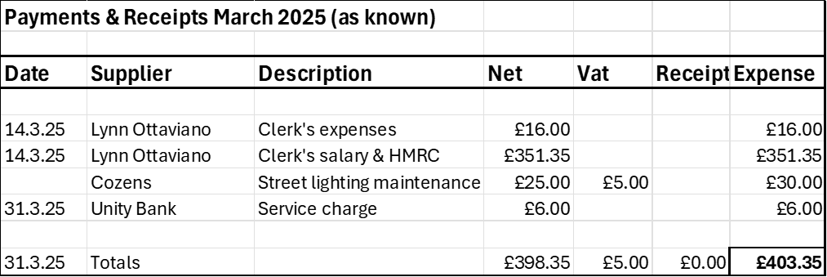

- To receive items for the next agenda.
Sleight’s Drive
Speed survey results

- The next Meeting will be the Annual Parish Meeting from 6:30 pm followed by the Parish Council meeting from 7.00pm on the 7th of May 2025 at the Village Hall.
The Chairman thanked everyone for attending. Meeting ended at 8.10pm.

